**Task Description:**

Create a custom docker image for nginx and deploy it using docker compose, where the volume bind mount should be at /var/opt/nginx location. Push the created custom docker image to your docker-hub.

**Step 1: Launch an instance in EC2 (Amazon linux 2023)**

**Step 2: To install docker**

*~ sudo dnf update -y*

*~ sudo dnf install -y docker*

*~ sudo systemctl start docker*

*~ sudo systemctl enable docker*

*~ sudo usermod -aG docker ec2-user*

*~ docker --version*

*~ docker info*

**Step 3: Install Docker compose**

*~ sudo curl -L "https://github.com/docker/compose/releases/download/v2.10.2/docker-compose-$(uname -s)-$(uname -m)" -o /usr/local/bin/docker-compose*

*~ sudo chmod +x /usr/local/bin/docker-compose*

*~ docker-compose --version*

**Step 4: Create Custom Docker Image for NGINX**

~ mkdir nginx_custom_docker

~ cd nginx_custom_docker

**Step 5: Create a file named nginx.conf with custom configuration**

**Step 6: Create a Dockerfile**

**Step 7: Build the Docker Image**

*~ docker build -t nginx_custom .*

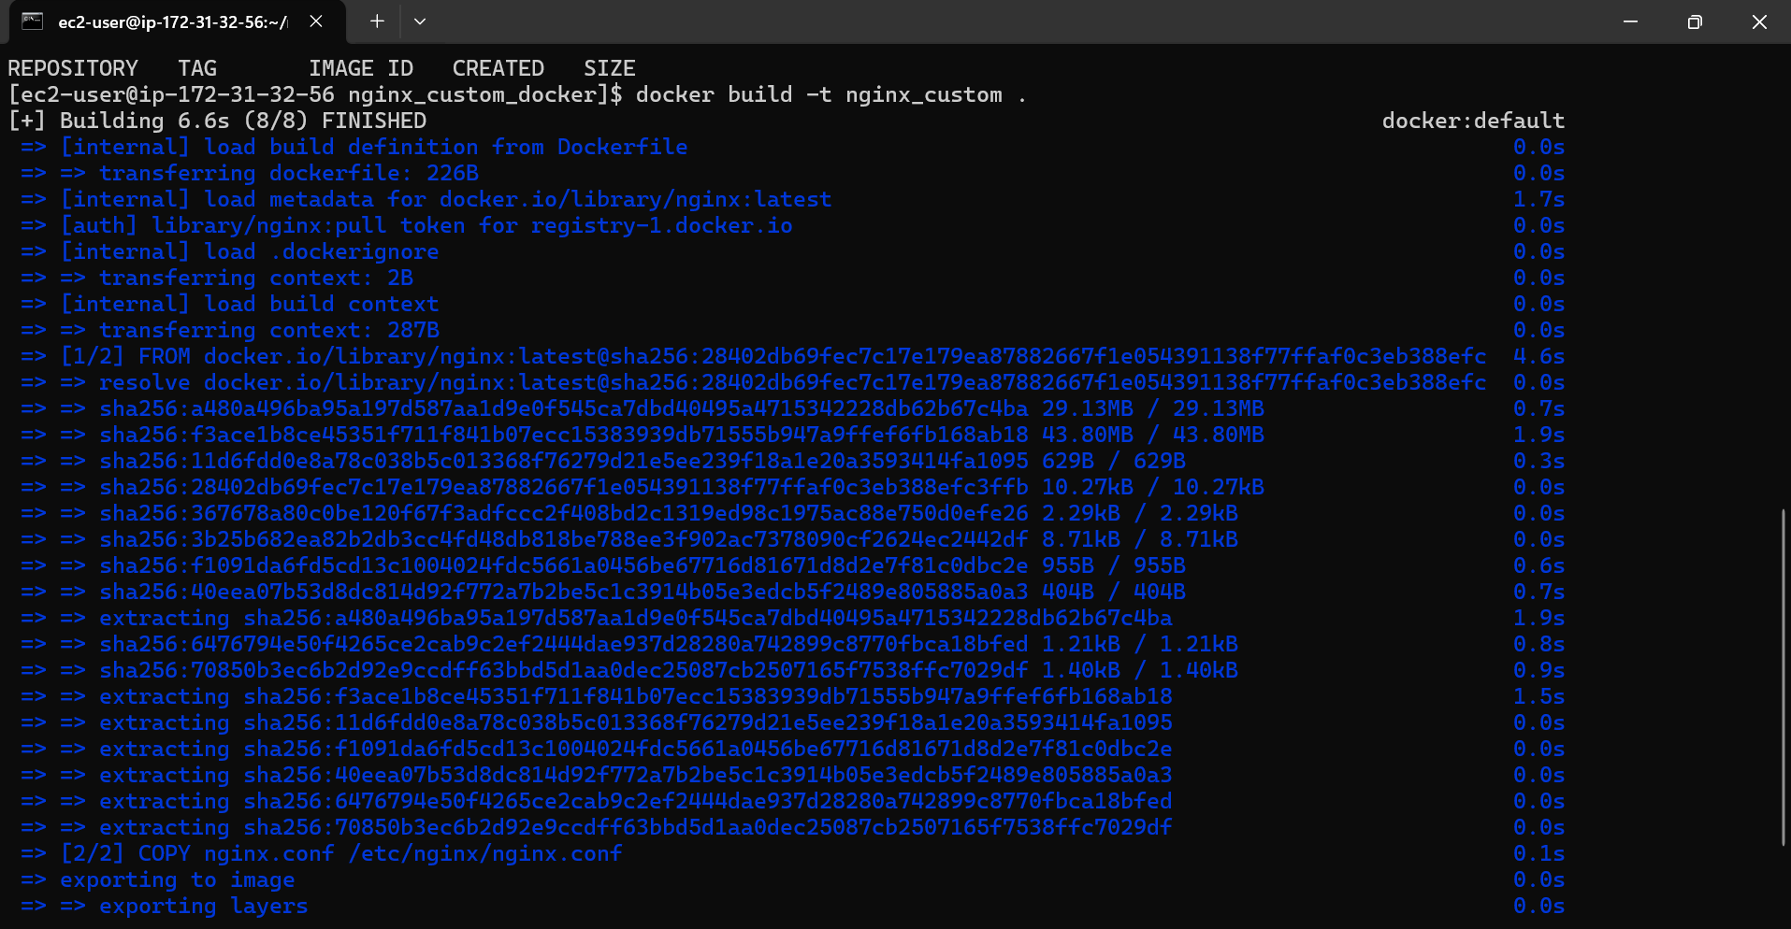

**Step 8: Log in to the Docker Hub**

~ docker login

**Step 9: Push the Image to Docker Hub:**

~ docker tag nginx_custom vignesh221193/nginx_custom:latest

~ docker push your_dockerhub_username/nginx_custom:latest

**Step 10: Create a docker-compose.yml File:**

**Step 11: Create a Directory for Bind Mount and run docker compose**

~ mkdir -p data

~ docker-compose up -d

**Step 12: Verify Container is Running**

~ docker ps

**Step 13: Access our NGINX Web Server:**

